

**SOFTWARE TESTING AUTOMATION**







Submitted by:

Dhanya. Ankolekar.

370CS20003

Submitted To:

Cohort: Dinesh Balgi

Department: Computer science

**Table of contents**

* What is software testing?
* Why Testing is important?
* What is agile?
* Advantages Disadvantages of Agile
* How is software testing in Agile different from normal testing
* Bug life cycle
* Type of software Testing
* Automation Testing
* Automation testing Tools
* Performance Testing

**AUTOMATION TESTING**

Automation testing is a Software testing technique to test and compare the actual outcome with the expected outcome. This can be achieved by writing test scripts or using any automation testing tool. Test automation is used to automate repetitive tasks and other testing tasks which are difficult to perform manually.

● Quickly Determine the Stability of Your

Build

● Immediate Feedback

● Fast Development and Delivery

● Increased Productivity

● Early detection of the defect

● Higher Test Coverage

**Automation Testing Tools**

**Automation Testing tools for**

**Functional Automation**

**❏ Selenium**

**❏ Appium**

**❏ Cypress**

**❏ Auto IT**

**❏ Geb**

**❏ HPE Unified Functional Testing**

**(UFT)**

**❏ EggPlant**

**Automation Testing tools for**

**Non-Functional Automation**

**❏ JMeter**

**❏ LoadRunner**

**❏ Wrk**

**Client and the requirements**

**A World leading supplier of aerospace fasteners and consumables, and a full service provider of inventory management solution for the commercial, business jet, and military markets.**

**To develop a best in-class reliable and reusable automation test framework for end to end testing of an ecommerce portal.**

**Technology Stack**

**We have used the top notch and market leading tech stack for developing the automation test framework. Which helped us to achieve the desired functionalities like -**

**● End to End testing**

**● Customizable reporting**

**● CI/CD integration**

**● Headless execution**

**● Write once and run anywhere on any machine (i.e. Machine Independent)**

**For this we have chosen -**

**● Geb & Spock Framework ( build on top of selenium)**

**● Gradle**

**● Groovy**

**● Bitbucket / Cron Jobs ( for continuous integration and execution)**

**Outcome**

**● Testing time reduction**

**● Increase testing coverage**

**● Higher feedback speed**

**● Quality improvement**

**● Proved to be helpful in regression testing**

**● Customizable and easily readable test reports.**

**● Easily encounters issues in static content and as well as complex business logics**

**● Reduced lot of pain of the testers**

**● Smallest issue could be caught and reported easily**

**● Close to accurate delivery which in return increased customers satisfaction**

**High level Test Execution Flow**

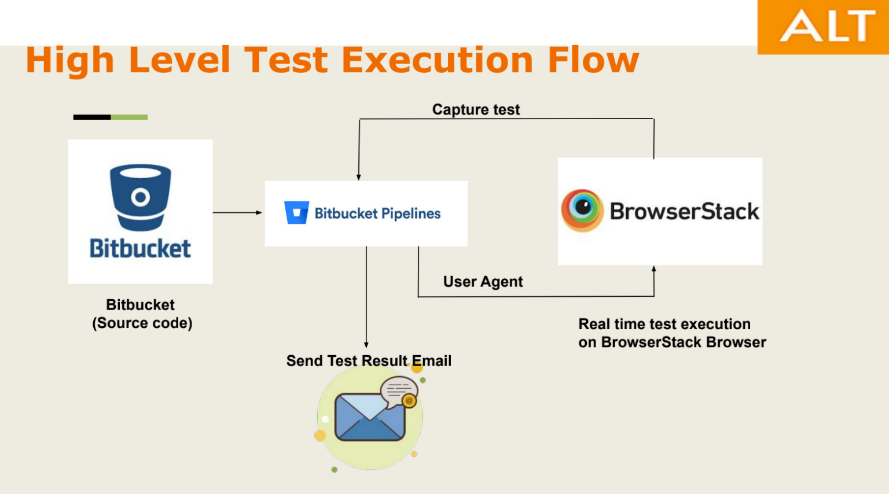

**Test Reporting**

**● Once all the test cases are executed, a test report is sent in an email**

**● Test execution summary is present in email body**

**● Test detailed report is attached as a zip file which can be downloaded & report traversed using index.html or same report can be directly accessed via link provide in the email**

**● We create the test report on the Behavior Driven Development given when-then format which makes it easily readable for non-developers**

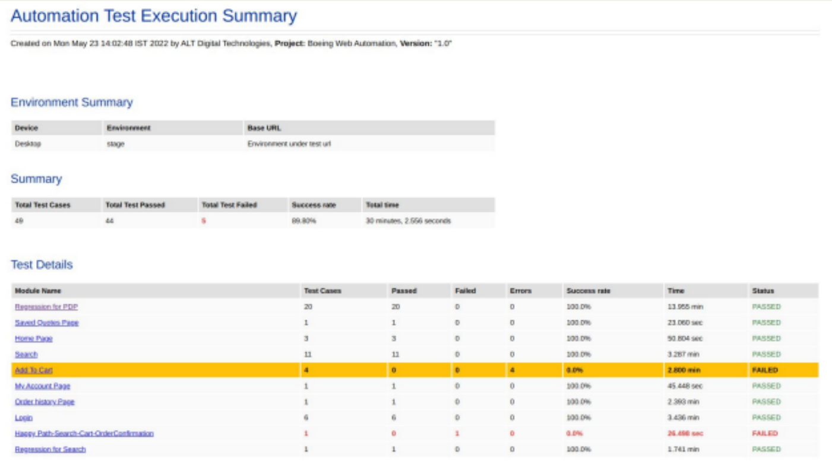

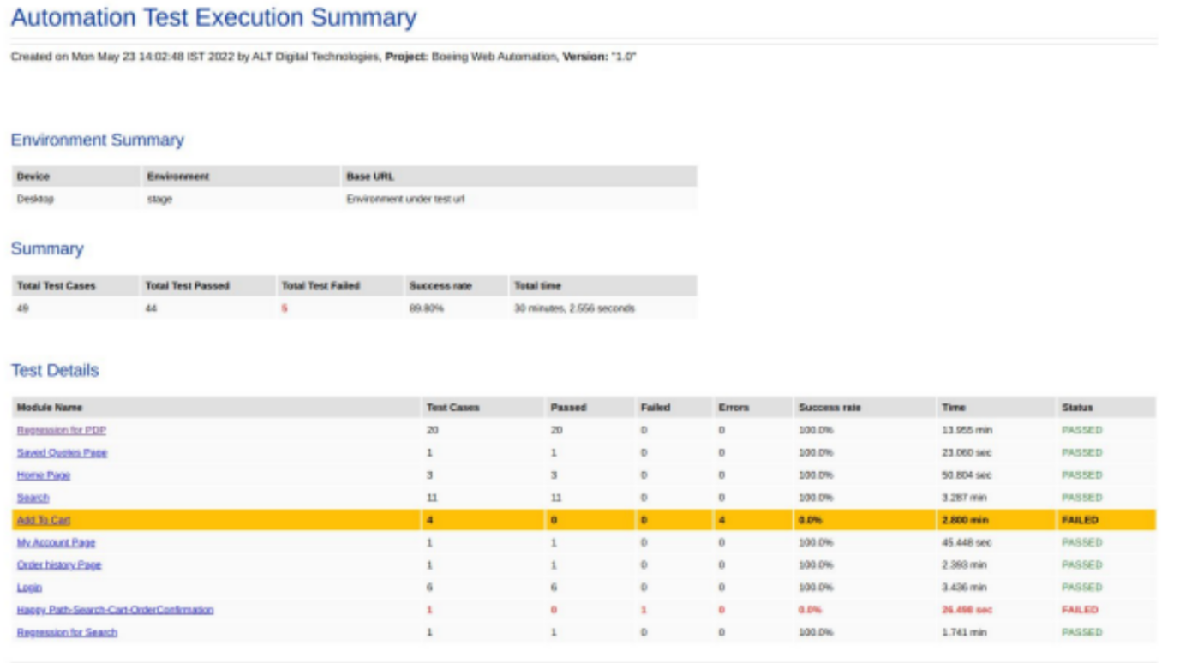

**Test Report Dashboard**

**Test Execution Summary for a specification Module**

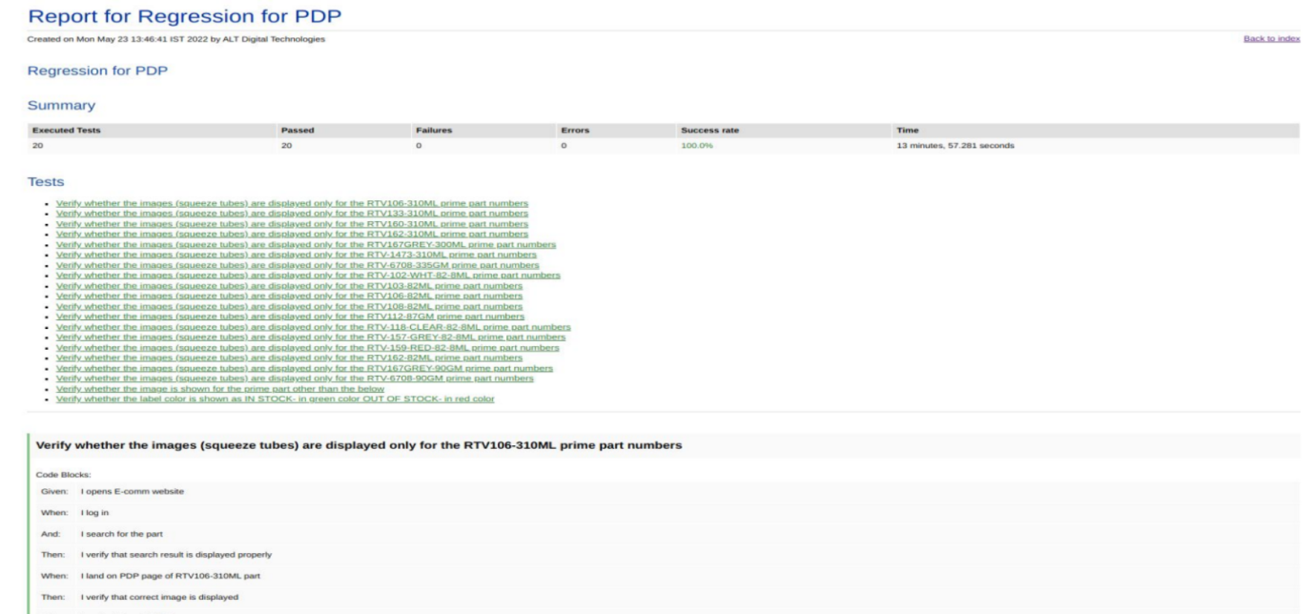

**Test Execution Command**

